Synopsis
On
ONLINE SHOPPING SYSTEM

by
Muskan Tomar (2000290140074)
Simran saifi (2000290140121)
Hritik Varshney (2000290140052)
Session: 2021-2022 (4th Semester)

Under the supervision of

Prof. (Dr.) /Mr. S.D. Mishra

(Ass . Professor)

KIET Group of Institutions, Delhi-NCR, Ghaziabad


DEPARTMENT OF COMPUTER APPLICATIONS
KIET GROUP OF INSTITUTIONS, DELHI-NCR,

GHAZIABAD-201206
(MARCH- 2022)

ABSTRACT

The Online Shopping is a web based application intended for online retailers. The main objective of this application is to make it interactive and its ease of use. It would make searching, viewing and selection of a product easier. It contains a sophisticated search engine for user 's to search for products specific to their needs. The search engine provides an easy and convenient way to search for products where a user can Search for a product interactively and the search engine would refine the products available based on the user’s input. The user can then view the complete specification of each product. They can also view the product reviews and also write their own reviews. The application also provides a drag and drop feature so that a user can add a product to the shopping cart by dragging the item in to the shopping cart. The main emphasis lies in providing a user-friendly search engine for effectively showing the desired results and its drag and drop behavior .

TABLE OF CONTENTS

- Introduction 2
- Literature Review 3
- Project / Research Objective 4
- Research Methodology 4
- Project / Research Outcome 5
- Proposed Time Duration 4
References 6

Introduction of Project
Shopping has long been considered a recreational activity by many. Shopping online is no exception. The goal of this application is to develop a web based interface for online retailers. The system would be easy to use and hence make the shopping experience pleasant for the users. The goal of this application is:
• To develop an easy to use web based interface where users can search for products, view a complete description of the products and order the products.
• A search engine that provides an easy and convenient way to search for products specific to their needs. The search engine would list a set of products based on the search term and the user can further filter the list based on various parameters.
• An AJAX enabled website with the latest AJAX controls giving attractive and interactive look to the web pages and prevents the annoying post backs.
• Drag and Drop feature which would allow the users to add a product to or remove a product from the shopping cart by dragging the product in to the shopping cart or out of the shopping cart.
• A user can view the complete specification of the product along with various images and also view the customer reviews of the product. They can also write their own reviews.

2. Literature Review

2.1 What is Online Shopping system :
Online shopping is a form of electronic commerce which allows consumers to directly buy goods or services from a seller over the Internet using a web browser or a mobile app. Consumers find a product of interest by visiting the website of the retailer directly or by searching among alternative vendors using a shopping search engine, which displays the same product's availability and pricing at different e-retailers. As of 2020, customers can shop online using a range of different computers and devices, including desktop computers, laptops, tablet computers and smartphones .

2.2 How does online Shopping system work :

The mission is to facilitate easy management and administration of a shopping with capabilities to do Booking or reservations of the products, Cancellation of the products, Cash billing, service, arrangement of products etc. using the automated online shopping management software. One can keep detailed records or info on an unlimited amount of customers. The system lets the user know which all products are available for occupancy at any point of time. This makes the booking considerably faster. And thus helps the online shopping in better management and reduce a lot of paper work as well as manpower.

Project Objective

The main objective of the online shopping System to manage is to manage the details of shopping , Internet , Payment, Bills ,Customer. It manages all the information about Shopping, Products, Customer , Shopping .The project is totally built at administrative end thus only the administrator is guaranteed the access .The purpose of the project is to build an application program to reduce the manual work the shopping ,Internet, Products Payment. It tracks all the details about the Payment, Bills , Customer.

This project have some more features:

- Provides the searching facilities based on various factors.

- The transaction are executed in off-line mode, hence on-line data for shopping.

- Manage the information of Internet

- Shows the information and description of the Shopping , Payment.

- All the fields such as Shopping, Payment, Customer are validate and does not take invalid values

- It generates the report on Shopping, Internet, Products

- You can also export the report into CSV format for shopping, Internet , Customer

- Manage the information of Bills

4 Research Methodology

Product information management
The product information management (PIM) module contains all the information related to the products in the e-commerce catalog. Some of the information managed by PIM includes:
- SKUs
- Title
- Descriptions
- Attributes
- Technical specifications
- Images

Shopping cart and checkout

The shopping cart allows customers to select and hold the products they wish to purchase. It tracks the user’s session, allowing them to leave the site and come back later with items still in their cart.
During the checkout process, the cart collects the customer’s payment information. This information is passed to the third-party payment processor. The details of the order are sent to other modules like the order management system (OMS), inventory management system, and customer relationship management (CRM) system.

Reports
This module deals with the generation of the reports for the various modules. The customer list can be generated. Product status list can be retrieved for reference. The check in and checkout registers can also be retrieved for any future queries.

5 Project Outcomes 6 Proposed Time Duration
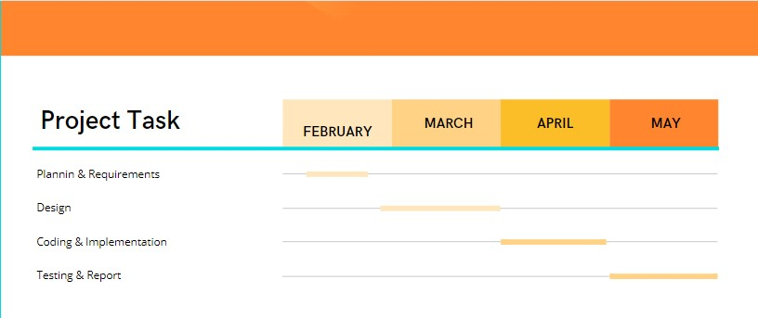

7- References
Book References
➢ PHP Programming Education | McGraw Hill
➢ PHP Projects Martin,Dominic Selly | Tony
➢ PHP Professional Projects Kaur,Pooja Bembey | Kuljit
➢ MY SQL The Complete Reference | George Koch

Internet References:

https://www.slideshare.net/Kkushum/online-shopping-system-69945887

https://dipeshagrawal.files.wordpress.com/2018/07/docuri-com_online-project.pdf
https://link.springer.com/chapter/10.1007/978-0-387-75734-6_9

REFERENCES

<Sample Format>

- "The Alibaba phenomenon". The Economics. March 23, 2013.
- Jump up to:ª ^{b} Lambert, Laura (2005). The Internet: A Historical Encyclopedia : Chronology. Vol. 3, Volume 3. Santa Barbara, CA: ABC-CLIO. p. 100. ISBN 978-1851096596.
- Botha, J.; Bothma, C.; Geldenhuys, P. (2008). Managing E-commerce in Business. Cape Town: Juta and Company Ltd. p. 3. ISBN 9780702173042.
- Zinkan, George (2011). Advertising Research: The Internet, Consumer Behavior, and Strategy. Chicago: American Marketing Association.

